

*Jewelry That Cares: Harnessing Smart Jewelry for Emotional Well-being*

*by. Gal Polak & Michal Ginat*

*advisor. Dr. Naomi Unkelos Shpigel*

*Software Engineering Department*

*Project Code : 24-2-D-7*

*Table of Contents:*

Abstract 3

1. Introduction: 3

2. Literature Review: 4

2.1 Prevalence of Anxiety: 4

2.2 Cognitive Behavioral Therapy (CBT) for Anxiety Management 5

2.3 Existing Application Introduction 6

2.4 Managing Anxiety with Smart Wearables and Smart Apps 8

2.5 Evaluating Modern Cross-Platform Mobile Development Solutions 9

3. Research 13

3.1 Interviews 13

3.1.1 Interviews Overview 13

3.1.2 Interviews Insights 16

3.2 Anxiety measure 17

3.3 Communication Protocols for Wearable Devices 19

4. Engineering Process 20

4.1 Development Process 20

4.2 System Architecture Overview 21

4.2.1 Technology Stack 21

5. Work Artifacts 22

5.1 FR & NFR Requirements 22

5.1.1 Functional Requirements Document: 22

5.1.2 Non-functional Requirements: 24

5.2 Use Case Diagram 29

5.3 Activity Diagram 30

5.4 Application Screen Sketches 31

6. Expected Achievements 34

6.1 Challenges 34

6.2 Success Criteria 34

7. Testing Plan 35

7.1 Scope 35

7.2 Objectives 35

7.3 Testing Approach 35

7.4 Constraints and Assumptions in Testing 36

7.5 Description of the Testing Work Environment 36

7.6 Test Cases 36

8. References 37

# Abstract

In today's fast-paced world, managing anxiety effectively is crucial for maintaining mental health and well-being. Managing anxiety remains a significant challenge due to the lack of integrated tools offering real-time monitoring and personalized interventions. This project explores the development of a novel mobile application designed to address these challenges by leveraging wearable devices equipped with sensors to detect anxiety attacks. To accurately measure anxiety, the app incorporates machine learning that analyzes various physiological and physical signals, such as heart rate and electrodermal activity. The app provides immediate calming actions, motivational success messages, and detailed tracking of anxiety attack frequency and duration. Insights from interviews with psychologists and a review of existing solutions shaped the app's features, ensuring it meets user needs and enhances long-term mental health management.

# 1. Introduction:

Anxiety disorders affect a significant portion of the global population, highlighting the urgent need for effective anxiety management solutions [18]. Recent events, such as the conflict in Israel that began on October 7, 2023, have intensified this need, leading to a noticeable rise in anxiety levels and an increase in related online searches [*7*]. These trends emphasize the growing demand for mental health support and the challenges therapists face in addressing widespread anxiety management needs [18].

To address this pressing issue, our project is developing an innovative smart wearable device paired with a dedicated app for real-time anxiety management. This solution employs advanced sensors and real-time data processing to offer a non-invasive, supportive tool. The wearable device continuously monitors signals, such as Electrodermal Activity (EDA), also known as Galvanic Skin Response (GSR) and Heart Rate Variability (HRV), which are reliable indicators of stress and anxiety [3].

Extensive discussions with psychologists revealed several key challenges therapists face, including maintaining real-time situational awareness, overcoming communication barriers, and accurately tracking and documenting anxiety episodes. These challenges underscore the need for tools that facilitate effective self-management and streamline therapeutic processes.

Integrating Cognitive Behavioral Therapy (CBT) techniques is a key aspect of our approach. CBT, a well-established and evidence-based treatment, guides our inclusion of strategies such as Relaxation Training, which aligns with our goal of providing structured and practical tools for managing anxiety [1]. Our research into existing anxiety apps revealed that only a small percentage involved mental health professionals in their development [4]. In response to this gap, our platform prioritizes professional involvement to ensure that our application is grounded in expert knowledge and effectively supports both patients and therapists.

The app features comprehensive documentation options, gamification elements for enhanced engagement, detailed metrics for therapists, privacy controls, and tools to improve patient-therapist contact. This comprehensive approach ensures that the application meets the real-world needs of its users and integrates the best practices from both research and clinical experience.

Our platform aims to bridge the gap between the growing demand for anxiety management and the limitations of traditional therapy models. By providing real-time support through wearable technology and CBT-based interventions, we empower individuals to manage their anxiety in the moment, during their daily lives. Through this innovative combination of technology, established therapeutic techniques, and expert guidance, our platform strives to improve human life by equipping individuals with the tools they need to navigate real-time anxiety situations and build long-term resilience.

The rest of the book examines the technological, organizational, and ethical aspects of our platform. It uses case studies and expert insights to explore challenges and solutions, highlighting the benefits of integrating advanced technology in this field.

# 2. Literature Review:

# 2.1 Prevalence of Anxiety:

Anxiety regularly maintains a fairly constant trend in terms of the Google searches that are created due to anxieties and their treatment. According to search data, there are dozens of weekly searches on the subject of anxiety, indicating its daily impact on people's lives.

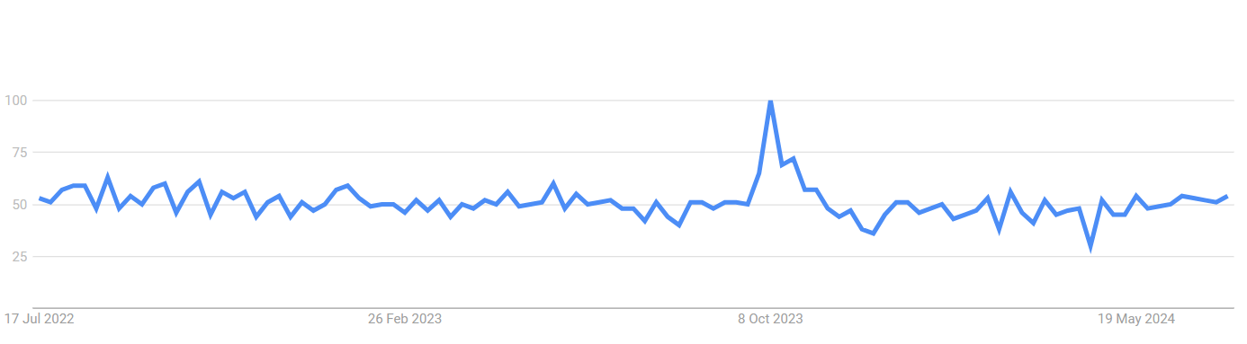

*fig 1. ‘Anxiety’ on google trends [7]*

Statistics show that globally, anxiety disorders affect approximately 4% of the population, translating to 301 million people as of 2019 [18]. The onset of the war on October 7, 2024, further intensified this interest according to the findings from Google searches *[7]*, highlighting the urgent need for mental health support and exacerbating the existing challenges therapists face in addressing the widespread demand for anxiety management.

The research carried out on the epidemiology of anxiety disorders highlights several critical points that relate closely to our application. Firstly, the global prevalence of anxiety disorders and their increase over the years emphasizes the significant and growing need for effective anxiety management solutions [18]. Our application, which integrates wearable technology with real-time monitoring and interventions, addresses this need by providing users with immediate support during anxiety episodes.

Additionally, the study underscores the importance of sociodemographic factors in the prevalence and management of anxiety disorders. It was found that anxiety is more prevalent in high-income regions and among women [18]. This insight is crucial for our application development, as it suggests the need for tailored features that consider these sociodemographic differences. By customizing interventions and providing personalized feedback, our application can offer more effective and inclusive support to a diverse user base.

# 2.2 Cognitive Behavioral Therapy (CBT) for Anxiety Management

Cognitive Behavioral Therapy (CBT) is a well-established, evidence-based treatment for anxiety disorders. It focuses on helping patients identify and challenge negative thought patterns and behaviors associated with anxiety. CBT has been proven effective for various anxiety-related disorders, including generalized anxiety disorder (GAD), social anxiety disorder (SAD), panic disorder, and post-traumatic stress disorder (PTSD) [1]. Given our project's focus on a target population treated with CBT, understanding and integrating CBT techniques is crucial.

Key Techniques in CBT:

Cognitive Restructuring: This technique helps patients identify and challenge irrational or maladaptive thoughts, replacing them with more realistic and positive ones [1​].

Exposure Therapy: Gradual exposure to feared situations or objects to reduce anxiety over time. This technique is particularly effective for treating phobias, panic disorder, and PTSD​ [1]​​ [19]​.

Mindfulness-Based Cognitive Therapy (MBCT): Combines traditional cognitive therapy with mindfulness strategies. It is used to prevent the recurrence of depression and to reduce anxiety [19]​.

Behavioral Activation: Encourages engagement in positive activities to improve mood and counteract patterns of avoidance, withdrawal, and inactivity​ [19]​​.

Acceptance and Commitment Therapy (ACT): Focuses on accepting unpleasant thoughts and feelings rather than fighting them. It encourages commitment to actions that align with personal values​ [19]​.

Dialectical Behavior Therapy (DBT): Combines cognitive-behavioral techniques with mindfulness and is effective for treating borderline personality disorder and other conditions involving emotional dysregulation ​[19]​.

Functional Analytic Psychotherapy: Focuses on improving interpersonal relationships by using therapeutic interactions to teach new ways of behaving​ [19]​.

Relaxation Training: Techniques such as deep breathing, progressive muscle relaxation, and guided imagery to reduce physical symptoms of stress and anxiety [1​].

Recent Advances and Meta-Analyses:

* Efficacy of CBT: Recent meta-analyses confirm the effectiveness of CBT in reducing anxiety symptoms and improving the quality of life for patients with anxiety disorders. These studies highlight significant positive outcomes for both individual and group therapy formats [1​].
* Long-Term Benefits: Evidence suggests that CBT provides long-term benefits in anxiety management, with patients maintaining improvements well beyond the end of treatment [1]​​ [19]​.

Some of the techniques reviewed, such as Relaxation Training, will be considered for use in treating anxiety within our target population. These methods align well with our project's goals to provide effective, evidence-based anxiety management tools. Integrating these CBT techniques into our application will enable us to offer structured, practical strategies that patients can use to manage their anxiety more effectively.

# 2.3 Existing Application Introduction

In the realm of mental health and wellness, numerous apps have been developed to help individuals manage stress, anxiety, and overall mental well-being. These apps employ a range of features, including professional involvement, gamification, and social interaction, to enhance user experience and effectiveness.

A comprehensive study published in the Journal of Biomedical Informatics [4] analyzed 167 highly-rated, free anxiety apps. The study categorized these apps based on their intervention approaches, professional involvement, gamification features, and social functionalities.

**Intervention Approaches:** The most common methods used were mindfulness (29 apps) and Cognitive Behavioral Therapy (CBT) (25 apps). Other approaches included hypnotherapy, artificial intelligence, brainwaves and frequencies, Dialectical Behavioral Therapy (DBT), and Autonomous Sensory Meridian Response (ASMR). Less common methods included Acceptance Commitment Therapy (ACT), spiritual or religious practices, biofeedback, and Positive Psychology.

**Professional Involvement:** Despite the effectiveness of these apps, only 19% of them reported involvement from mental health professionals in their development.

**Gamification Features:** Gamification was used in 51% of the apps to boost user engagement. Common features included games, graphics, goals, levels, challenges, and the ability to unlock new features or earn rewards.

**Social Features:** 32% of the apps incorporated social features such as chat, progress sharing, links to relevant resources, and emergency contact information.

In response to the limited availability of anxiety apps with professional involvement, we have developed a new platform that incorporates this critical feature among others.

The following findings provide a detailed comparison of two prominent devices that interface with anxiety management applications: the **Spire Stone** and the **Feel by Sentio Solutions**.

| **Feel by Sentio Solutions** | **Spire Stone** | **Feature** |
| --- | --- | --- |
| Modern wristband; worn on the wrist | Small, stone-shaped device; clips onto clothing | Design and Wearability |
| Multi-sensor: HRV, skin conductance, temperature | Respiratory sensors; tracks breathing patterns, activity | Sensors and Monitoring |
| Real-time alerts for elevated stress; personalized recommendations | Real-time alerts for stress detected via breathing patterns; prompts breathing exercises | Alerts and Notifications |
| iOS and Android | iOS and Android | Mobile App Features |
| Up to 24 hours on a single charge | Around 7 days on a single charge | Battery Life |
| USB cable | Wireless charging pad | Charging |
| Water-resistant (suitable for everyday use, not for swimming) | Water-resistant (suitable for everyday use, not for swimming) | Water Resistance |
| Customizable color options; more variety in design | Limited color options; typically available in basic colors | Personal Design (Color) |
| Adjustable wristband; fits most wrist sizes | One-size-fits-all; clips onto clothing | Size |
| Some gamification; includes mood tracking and progress milestones | Limited gamification; focuses on mindfulness and breathing exercises | Gamification Features |
| Significant; developed with mental health professionals' input, includes access to licensed therapists | Limited; focused on mindfulness and breathing, with no direct professional input or support | Professional involvement |
| No built-in feature for notes or recording; focuses on real-time feedback and recommendations | No built-in feature for notes or recording; relies on app insights | Documenting Experience |
| Guided Breathing Exercises: Breath Awareness, Stress-Relief Breathing  Mindfulness and Meditation: Guided Meditation Sessions, Body Scan  Mood Tracking and Recommendations: Personalized Recommendations, Daily Check-Ins | Guided Breathing Exercises: Deep Breathing, Focused Breathing  Mindfulness Meditation: Short Meditations, Mindfulness Reminders  Breathing Exercises for Different States: Calm, Focus | Relaxing Exercises |

*Table1: existing devices examination*

This table compares two anxiety management wearables—Feel by Sentio Solutions and Spire Stone—highlighting their key features to support users in managing stress and anxiety. It covers aspects like mobile app compatibility, sensor technology, and personalized recommendations, helping users identify which device best suits their needs. While both tools offer valuable features for anxiety management, neither provides a fully integrated solution that addresses all aspects of mental well-being. To fill this gap, we aim to develop a solution that would combine essential features like professional support, personalized insights, and real-time monitoring into a single, user-friendly platform.

# 2.4 Managing Anxiety with Smart Wearables and Smart Apps

The integration of wearable devices with mobile applications has become essential for effectively managing anxiety and other mental health conditions. Wearable sensors, such as electrodermal activity (EDA) and heart rate monitors, allow continuous monitoring of physiological signals, providing real-time detection of stress and anxiety. When paired with smart applications, these devices offer personalized feedback and interventions, helping users manage their anxiety more effectively. For instance, the DEWS project demonstrates the potential of wearable systems to offer real-time health monitoring and timely alerts, which can be crucial for handling acute anxiety episodes and potentially saving lives [2]. Additionally, smart devices equipped with advanced algorithms provide actionable insights and recommendations, enabling users to adopt calming strategies and make informed decisions about their mental health [6]. The incorporation of IoT technology enhances these capabilities by ensuring seamless communication between devices and healthcare providers, enabling continuous data flow and timely interventions. This technology not only enhances individuals' ability to cope with anxiety but also supports healthcare professionals in delivering more targeted and efficient care.

# **2.5 Evaluating Modern Cross-Platform Mobile Development Solutions**

In recent years, cross-platform mobile application development has gained significant traction due to its ability to streamline development processes and reduce costs. Among the various frameworks available, Flutter and React Native have emerged as popular choices for developers. This review compares these two advanced client-side technologies, examining their features, performance, and suitability for modern mobile app development.

| **Aspect** | **Flutter** | **React Native** |
| --- | --- | --- |
| Introduction Year | 2017 | 2015 |
| Developed By | Google | Facebook |
| Programming Language | Dart (may require learning a new language) | JavaScript (widely known, easier to find developers) |
| Performance | Generally faster, especially for complex UI | Good performance, but may be slower for complex animations |
| App Size | Smaller app size (4.7 MB for "Hello World") | Larger app size (7 MB for "Hello World") |
| Learning Curve | Steeper if you don't know Dart, but consistent across platforms | Easier if you know JavaScript, but may require platform-specific knowledge |
| Development Environment | Windows, Mac OS, Linux | Windows, Mac OS, Linux, Online (Expo) |
| Hot Reload Support | Supported | Supported |
| Supported Operating Systems | Android, iOS, Windows | Android, iOS, Windows |
| UI Components | Rich set of customizable widgets | Relies more on third-party libraries for custom components |
| Native Feature Access | Better native feature access with less dependency on third-party libraries | More dependent on third-party libraries for native features |
| Community Support | Growing rapidly, but smaller than React Native | Large, established community with more resources |
| Third-party Library Support | Fewer options, but growing | Extensive third-party library ecosystem |
| Real-time Updates | Good support for real-time features | Good support for real-time features |
| Popularity | Rapidly growing, particularly popular among new projects | Very popular with a large existing codebase and community support |

*Table2. Client-side technologies comparison [5]*

Flutter and React Native are advanced technologies for mobile app development, each with its strengths. Flutter excels in performance, UI consistency, and native feature access, making it ideal for complex interfaces or deep hardware integration. React Native, with its JavaScript foundation, is better for teams with web development expertise and projects needing various third-party libraries. The choice depends on project requirements, team skills, and goals. Both frameworks are evolving, offering powerful tools for efficient, high-performance cross-platform mobile app development.

We are evaluating popular backend technologies for our upcoming mobile app to ensure a robust and scalable solution, focusing on Node.js and Django.

| **Feature** | **Node.js** | **Django** |
| --- | --- | --- |
| Programming Language | JavaScript | Python |
| Architecture | Event-driven, non-blocking I/O, suitable for real-time applications | Synchronous (asynchronous capabilities can be integrated), suited for rapid development with a clean, pragmatic design |
| Popularity | Extremely popular for full-stack JavaScript development, large community, supported by major tech companies | Very popular, especially among startups and for rapid development, large community |
| Ecosystem | Extensive npm library and active community | Strong community, extensive documentation, rich ecosystem |
| Performance | High performance under load, handles concurrent requests efficiently | Good performance, especially for CRUD (Create, Read, Update, and Delete) applications, with robust handling of database operations through ORM(Object-Relational Mapping) |
| Learning Curve | Moderate, depends on familiarity with JavaScript and asynchronous programming | Moderate, Python's straightforward syntax makes it accessible, though mastering Django’s full capabilities takes time |
| Integration | Seamless integration with other JavaScript frameworks and tools | Excellent support for front-end frameworks via Django REST Framework, which simplifies API creation for mobile apps |
| Best for | Real-time applications such as chat apps or apps requiring constant data updates | Projects where rapid development and admin capabilities are important, such as content management systems and complex databases |

*Table 3. Server-side technologies comparison [8] [9]*

Both React Native and Flutter integrate well with popular backend technologies like Node.js and Django. React Native pairs naturally with Node.js due to their shared JavaScript environment, and it also works effectively with Django through RESTful APIs​ [10]​​​. Flutter supports integration with Django via HTTP requests and can use Node.js for real-time data handling and high traffic support​ [10[]​​​​](https://www.lambdatest.com/blog/flutter-vs-react-native/%5D%E2%80%8B%E2%80%8B%E2%80%8B%E2%80%8B).

We have examined MongoDB and PostgreSQL, two leading databases, for the development of our mobile application. These databases were chosen due to their robust features, scalability, and widespread popularity in modern web and mobile applications [11]. We need to store user notes and recordings, which involves handling a lot of text and binary data, so we researched the best options for our requirements.

| Aspect | MongoDB | PostgreSQL |
| --- | --- | --- |
| Data Model | Document-oriented (JSON-like documents) | Relational (tables and rows) |
| Scalability | Horizontal (sharding) | Vertical (with extensions for horizontal) |
| Query Language | MongoDB Query Language (JSON-like) | SQL |
| Performance | High for read/write, flexible schema | Strong for complex queries, structured data |
| Transactions | Multi-document transactions (limited) | Full ACID (Atomicity, Consistency, Isolation, and Durability) compliance |
| Use Cases | Real-time analytics, flexible schema, unstructured data | Financial systems, complex transactions, structured data |
| Market Position | Popular for startups, fast-growing, adaptable | Established, reliable for critical applications |

*Table 4. DataBase technologies comparison [15][11][16]*

# 3. Research

# 3.1 Interviews

To gather accurate and actionable data for the development of our anxiety management application, engaging directly with experienced psychologists in the field was essential. Interviews with therapists provided invaluable insights into the unique challenges and requirements faced by individuals managing anxiety. These discussions guided the development of our application, which communicates with a wearable piece of jewelry equipped with sensors to detect anxiety attacks. Through these discussions, we were able to understand the complexities of anxiety management and identify specific features and functionalities that our application must include to effectively support the needs of both patients and therapists. This collaboration ensured that our app is tailored to meet real-world requirements, ultimately enhancing its practicality and effectiveness in managing anxiety.

# 3.1.1 Interviews Overview

1. **Michal Meidan** - A clinical psychologist with 20 years of experience, owning a clinic in Afula and working at Emek Hospital. Holds a Ph.D. in clinical psychology and specializes in trauma and emotional regulation.

During the interview with the psychologist, key insights were shared about the symptoms, types, and treatment strategies for anxiety. Symptoms include avoidance behaviors, difficulty breathing, sweating, and rapid heartbeat. Different types of anxiety were discussed, such as specific phobias, generalized anxiety, and anxiety triggered by trauma, like hearing certain sounds or seeing specific objects that recall past traumatic events.

The psychologist emphasized that anxiety acts as a signal that something is unbalanced in the individual’s life. Triggers often stem from past traumas and can vary greatly among individuals.

Treatment strategies depend on the type of anxiety but generally include gradual exposure to feared situations, breathing techniques, grounding techniques (fire, water, earth), mindfulness, guided imagery, and advanced techniques like the butterfly technique (hands are crossed on the chest with alternating drumming on the shoulders while verbalizing anxiety-inducing thoughts, followed by calming statements).

When asked about integrating our smart wearable device with her treatment routine, the psychologist highlighted its potential to assist patients, especially those with post-traumatic stress, by helping them reconnect with their bodies and recognize their anxiety in real-time. This is particularly valuable for patients who may not be aware they are experiencing anxiety due to dissociation.

The psychologist expressed that she would not want real-time notifications due to time constraints but suggested that a diary feature within the app could be beneficial. This diary should include entries for date, time, emotion, thought, and behavior, providing both the patient and the psychologist with insights into triggers and patterns. Frequency and intensity of anxiety episodes would also be valuable data.

Recognizing that patients may lack motivation to document their experiences, she suggested that voice recording could be an easier alternative for some patients. Additionally, when the app detects anxiety, it could prompt the patient to practice breathing exercises with a message like, "You are experiencing anxiety, now is the time to breathe."

The psychologist also noted the challenge of maintaining patient motivation between sessions. She recommended incorporating incentives based on measuring successes, such as completing exercises or using coping strategies, to encourage regular app use.

Finally, she suggested exploring biofeedback as it could enhance the functionality of our wearable device and app, helping patients better understand and manage their anxiety symptoms.

1. **Rivka Amir** - A psychologist and psychotherapist with 20+ years of experience, owning a private clinic in Megiddo and working at Emek Yezreel College with nursing students, primarily focusing on emotional issues. Additionally, she treats patients at the Sexual Trauma Center in Afula.

During the interview with the psychologist, several key insights emerged regarding the diagnosis, management, and treatment strategies for anxiety. The psychologist noted that patients often arrive with a diagnosis from a psychiatrist and accompanying medication, or with clinical symptoms such as sweating, heart palpitations, sleep disturbances, breathing issues, flashes, fainting, dissociation, or even rage attacks.

Various types of anxiety were discussed, including academic anxiety, performance anxiety, and anxiety related to past or present traumas like sexual assault, domestic violence, and abusive relationships, as well as social anxieties.

For extreme cases, the psychologist emphasized the necessity of psychiatric treatment, though it is often not sufficient alone. Common non-extreme treatments include breathing techniques (e.g., inhaling for 4 seconds and exhaling for 8 seconds) and grounding techniques (e.g., sitting on the floor to feel stability). These techniques help shift the brain's focus from the amygdala (fear center) to the hippocampus (cognitive areas), aiding in anxiety management.

A notable example involved a patient who found comfort in playing with a pearl necklace during anxiety attacks, as the pearl reminded her of her calming sister, Perla. This emphasizes the importance of having a wearable item with significant meaning.

The psychologist highlighted the advantage of our wearable device combined with the app, as therapy typically occurs once a week, and patients can experience numerous episodes between sessions. The app and wearable can provide support when needed, as anxiety often impairs memory, making it hard for patients to recall coping strategies in real-time.

Regarding documenting experiences, the psychologist mentioned that some patients might succeed in turning their experiences into narratives with a beginning, middle, and end, which can be calming. The app should be able to record the frequency and duration of these events and display graphs to track progress.

In terms of real-time feedback during anxiety attacks, features like guided breathing exercises, personal journaling, and grounding techniques can be beneficial. The psychologist emphasized the need for personalized adjustments to these interventions, such as adding specific sounds or songs that might be calming.

For motivation, the app could incorporate elements similar to Clalit Active, offering coins and rewards for activities like using the app and employing anxiety-reducing techniques during attacks. Notifications like "You successfully calmed down in X minutes" or "Well done, you handled the anxiety attack well" can provide positive reinforcement.

When asked if patients would use the app and wearable device, the psychologist affirmed that many would, though those with severe cases might struggle. The combination of a smart wearable that provides feedback without drawing attention was seen as particularly valuable.

1. **Elad Tal** - A psychologist with clinics in Haifa and Megiddo, targeting adults, couples, and families. He is also involved in the "Mifrasim" project, which aims to foster personal and team development for diverse groups, including underserved communities. The target audience of the program includes individuals dealing with bereavement, physical or emotional trauma, offering them unique therapeutic experiences through group sea voyages and the benefits of sailing.

During our interview with the psychologist, several key insights emerged regarding the development and use of an app and wearable device for managing anxiety. The psychologist noted that not all patients are suited for this type of therapy; the focus should be on cognitive-behavioral therapy (CBT) rather than more internal, psychodynamic treatments.

In discussing strategies for managing anxiety in real-time, the psychologist emphasized the effectiveness of providing patients with a note containing calming instructions. The psychologist highlighted concerns about using rapid dial features, noting that a lack of immediate response can increase anxiety. However, this feature could be life-saving in certain scenarios.   
The psychologist provided an example of a sexual assault survivor going on a date, demonstrating that calming texts can effectively reduce anxiety without the need for direct intervention from someone close, thus enabling the individual to manage their anxiety independently without feeling exposed or interrupted during crucial moments.

The wearable device combined with the app can reassure patients by providing support during anxiety-inducing situations. The psychologist emphasized the importance of allowing patients to control what information they share with their therapists, similar to how they decide what to disclose during sessions. With patient consent, the psychologist would like the information to include details on the frequency, intensity, triggers (as documented by the patient), and duration of anxiety attacks.

The psychologist also noted that incorporating in-app incentives, such as motivational feedback like "Well done, you handled the anxiety attack well," can boost patient morale and motivation to use the app regularly. This feedback provides positive reinforcement and encourages continued use of the application.

Overall, the insights from All interviews have been instrumental in shaping the development of the app, ensuring it meets the real-world needs of both patients and therapists effectively.

# 3.1.2 Interviews Insights

The interviews highlighted several recurring themes:

* **Anxiety Treatment Techniques:** Therapists emphasized a variety of effective methods, such as:
* Breathing exercises
* Exposure therapy
* Grounding techniques
* Guided imagery
* Relaxation methods, including relaxing videos
* Importance of patient choice in selecting preferred techniques to enhance engagement and effectiveness.
* **Physiological Measures:**
* Heart rate and sweat levels in breathing were identified as valuable indicators of anxiety.
* Most therapists expressed that they do not want to receive real-time alerts about their patients' anxiety episodes.
* **Critical Features of the Application:**
* **Documentation:**

Support for both written and audio documentation. Enables patients to comprehensively record their experiences, triggers, and interests.

* **Gamification:**

Offering rewards like points or coins. Provides positive feedback for progress.

* **Feedback to Doctors:**

Metrics such as the frequency, intensity, and duration of anxiety episodes. Inclusion of patient-written descriptions.

* **Privacy Control:**

Patients should have control over their privacy. Allow patients to decide which parts of their documentation to share with their therapist.

* **Patient-Therapist Contact:**

Many patients struggle to recognize and record their anxiety episodes as they occur. Therapists face challenges in maintaining consistent follow-up between sessions due to patients' difficulty in recalling their anxiety experiences. The application helps patients connect with their bodily sensations and emotions, enabling them to better identify and manage their anxiety in real-time.

# 3.2 Anxiety measure

Measuring anxiety involves capturing how individuals respond to anxiety through various physiological and physical signals. Given that anxiety manifests differently from person to person, influenced by factors such as body condition, age, gender, and experience, establishing universally accepted numerical values for anxiety indicators remains challenging.

To address these variables, computational techniques like artificial neural networks and fuzzy logic are employed to manage the uncertainties in defining stress *[20]*. As a result, machine learning is increasingly utilized to improve anxiety detection.

Interestingly, traditional psychophysiology studies, which do not utilize machine learning techniques, often fail to show significant correlations between physiological measures and subjectively rated anxiety levels. This highlights a critical limitation of conventional methods, which can struggle to accurately detect anxiety. The study *[17*] found that traditional methods alone were insufficient for accurate anxiety detection, reinforcing the importance of integrating deep learning to achieve more precise and reliable results.

Common methods for assessing anxiety include analyzing physiological signals such as electroencephalography (EEG), blood volume pulse (BVP), heart rate variability (HRV), galvanic skin response (GSR), and electromyography (EMG). Additionally, physical signals including eye gaze, pupil diameter, voice characteristics, and facial movements are also monitored. Figure 2 illustrates the common physical and physiological measures used to detect stress and their typical sources.

*fig 2. usual sources for the measures [20]*

Under anxiety, notable changes occur in heart rate, blood pressure, pupil diameter, breathing patterns, and galvanic skin response. Electrodermal Activity (EDA), also known as GSR, measures variations in skin electrical conductance, which increases with emotional arousal and stress due to sweating. The data indicates that Electrodermal Activity (EDA), heart rate (HR), and accelerometers are among the most prevalent physiological signals utilized for stress detection *[3*]. Notably, the combination of EDA and HR has demonstrated the highest performance in these settings, with accuracies surpassing 95%. The research also highlights that Linear Discriminant Analysis (LDA), Support Vector Machines (SVM), k Nearest Neighbors (kNN), and Fuzzy Logic classifiers are some of the most effective machine learning algorithms for detecting anxiety. For instance, EEG signals achieved an 89% accuracy in four-class stress classification; however, the use of EEG devices remains challenging due to their obtrusiveness in everyday scenarios.

After a thorough search for suitable models, including a review of neat code with a dataset and referenced articles, we discovered a valuable resource available *[12*] . The repository contains code for anxiety level detection in arachnophobic individuals using supervised machine learning algorithms. The physiological signals used include ECG (Electrocardiogram), GSR (Galvanic Skin Response), and RESP (Respiratory signal). These signals were pre-processed, and the necessary features were extracted. The dataset can be downloaded from the provided link.

Remarkably, this approach achieved an accuracy of 89.8% for two-level classification and 74.4% for three-level classification using a short time window length of ten seconds. The method utilized subjective ratings for data labeling, and Bagged Trees proved to be the most suitable classifier among those studied [17].

In a related effort, another study explored the detection of subclinical social anxiety in young adults using physiological data obtained from wearable sensors, such as Heart Rate (HR), Skin Temperature (ST), and EDA [21]. The full dataset and code to recreate the classification models are available in a corresponding [13], which also includes functions for further experimentation .

Another approach to detecting anxiety involves developing our own classification model by sourcing an appropriate dataset and applying machine learning algorithms. This method would enable us to tailor the model to our specific requirements, potentially enhancing its accuracy and performance.

In our ongoing work, we will explore and evaluate these approaches—using existing models like the ones available on GitHub or developing our own classification models with machine learning algorithms. By thoroughly analyzing the performance and accuracy of each method, we aim to determine which approach is best suited to our specific needs. This process will guide us in selecting the most effective strategy for accurate and reliable anxiety detection tailored to our objectives.

# 3.3 Communication Protocols for Wearable Devices

Wearable devices for health monitoring are pivotal in decoding anxiety and other emotional states. The data collected by these sensors is often transmitted to cloud services for storage and analysis, from where it can be retrieved for further use. This review explores various communication protocols used to extract data from the cloud and the compatibility of these protocols with different cloud platforms.

**HTTP/HTTPS**: HTTP and HTTPS are the most commonly used protocols for retrieving data from the cloud through RESTful APIs. These protocols are supported by all major cloud providers and are ideal for applications requiring standard web communication. Data collected by wearable devices is transmitted to the cloud using BLE or Wi-Fi and stored in cloud databases. HTTP/HTTPS can then be used to pull this data for analysis and application integration [22] [14].

**MQTT (Message Queuing Telemetry Transport)**: MQTT is a lightweight messaging protocol designed for low-bandwidth, high-latency networks. It is commonly used in IoT applications for real-time data exchange. Wearable devices transmit data to an MQTT broker, which forwards it to the cloud. Devices can subscribe to MQTT topics to receive data in real-time [22]​ [14].

**WebSockets**: WebSockets provide a full-duplex communication channel over a single TCP connection, allowing real-time interaction with the cloud service (bidirectional communication). This protocol is beneficial for applications requiring continuous data streaming. Cloud platforms like AWS, Azure, and Google Cloud support WebSocket servers for real-time data exchange​ [14].

**CoAP (Constrained Application Protocol)**: CoAP is designed for simple electronics and constrained IoT devices, optimized for low-power and lossy networks. It is similar to HTTP but more lightweight. Devices can use CoAP to request data from a CoAP server in the cloud​ [22].

Various communication protocols such as HTTP/HTTPS, MQTT, WebSockets, and CoAP play crucial roles in extracting data from the cloud for wearable devices. These protocols ensure efficient, reliable, and secure data retrieval, enabling continuous monitoring and real-time analysis of data for anxiety detection. The choice of protocol depends on the specific requirements of the application and the cloud platform in use, with AWS, Azure, and Google Cloud offering robust support for these protocols.

# 4. Engineering Process

# 4.1 Development Process

The development process of our project involved several key steps to ensure a thorough and effective application design and implementation:

**Preliminary Literature Survey :** The development process began with a preliminary literature survey to better understand and focus on the main issues related to anxiety management and wearable technology. This step was crucial in identifying the most relevant trends and technologies in the field.

**Conducting Interviews:** Following the literature survey, we conducted interviews to gather opinions and gain deeper insights into the subject. These interviews helped direct what should be included in our application and identify the most needed features.

**In-Depth Literature Survey:** After the interviews, we conducted a more focused literature survey. The insights from the interviews helped us identify specific topics to delve into further, ensuring that our application addresses the most critical areas and benefits the users in the best possible way.

**Researching Recommended Technologies:** We continued with various research processes regarding recommended technologies. This step was vital in deciding how best to develop our system optimally and smoothly, ensuring it meets our system requirements.

**Formulating Application Requirements:** After conducting the literature review, research, and interviews, we formulated the application's requirements. This involved determining the main focus of our project and identifying the key functionalities and features needed.

**Creating UML Diagrams:** To provide a static view of the system classes, their attributes, service operations, and the interrelationships between objects, we created UML diagrams. These diagrams offer an overall view of the application, ensuring a well-structured and coherent system design.

**Sketching Application Interfaces:** We sketched the application interfaces, representing the main screens expected to be significant parts of the application. These sketches helped visualize the user experience and design the UI/UX elements effectively.

**Developing a Testing Strategy:** We established project expectations and developed a comprehensive testing strategy. This strategy included unit tests, integration tests, and usability checks.

**Implementing Code:** Finally, we implemented the application code alongside rigorous testing to verify that the expected outcomes were achieved. The development process ensured that the application was reliable, effective, and tailored to help users manage anxiety efficiently.

# 4.2 System Architecture Overview

Our system architecture is designed to integrate various technologies to deliver a robust and scalable solution for our mobile app and wearable jewelry. This design focuses on ensuring a seamless user experience, effective data management, and secure user authentication.

# 4.2.1 Technology Stack

**Server:** Node.js with Express.js serves as the backbone of our microservices architecture, handling API requests and interactions between the mobile app and cloud services.

**Data Management:** MongoDB provides flexible and scalable data storage, essential for managing diverse data types, including text and binary data.

**Frontend Technologies:** The mobile application is built using React Native, delivering a responsive and high-performance user interface for both Android and iOS platforms.

**Authentication:** Firebase Authentication is utilized for secure user management, incorporating features such as multi-factor authentication to enhance security.

**Communication Protocol:** WebSocket is employed for real-time data transmission between the mobile application and cloud services, ensuring efficient and reliable updates.

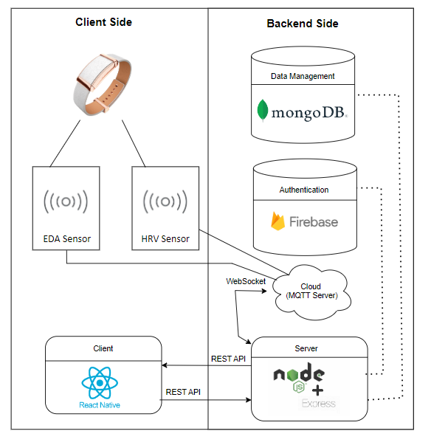

*fig 3. System Architecture diagram*

The diagram (fig 3) illustrates our system architecture, which integrates a mobile application, backend server, and cloud-based services. The mobile application, developed with React Native, communicates with a backend server powered by Node.js and Express.js. This server manages API requests and interactions with cloud services (MQTT server). Cloud services handle data from wearable jewelry, processing and storing it as needed. MongoDB is used for flexible and scalable data storage, while Firebase Authentication provides secure user management. Real-time data transmission between the mobile app and cloud services is managed using WebSocket.

# 5. Work Artifacts

# 5.1 FR & NFR Requirements

# 5.1.1 Functional Requirements Document:

| **No.** | | **Requirement** |
| --- | --- | --- |
| 1 |  | The System shall support user registration and login |
|  | 1.1 | The System shall provide patient registration with personal settings |
|  | 1.2 | The System shall provide therapist registration with professional details |
|  | 1.3 | The System shall allow login for patients |
|  | 1.4 | The System shall allow login for therapists |
| 2 |  | The System shall provide an initial settings process for patients |
|  | 2.1 | The System shall allow patients to select a therapist from a list of available therapists during the initial settings process |
|  | 2.2 | The System shall provide options during the initial settings for patients to set notification preferences for anxiety episodes |
|  | 2.2.1 | The System shall allow patients to enable or disable vibration notifications |
|  | 2.2.2 | The System shall allow patients to enable or disable sound notifications |
|  | 2.2.3 | The System shall allow patients to enable or disable popup text notifications |
|  | 2.3 | The System shall provide options during the initial settings for patients to set notification preferences for the end of anxiety episodes |
|  | 2.3.1 | The System shall allow patients to enable or disable reminders to write documentation notes |
|  | 2.4 | The System shall provide options during the initial settings for patients to select calming actions |
|  | 2.4.1 | The System shall allow patients to optionally choose a relaxing song |
|  | 2.4.2 | The System shall allow patients to optionally choose breathing exercises |
|  | 2.4.3 | The System shall allow patients to optionally choose grounding exercises |
|  | 2.4.4 | The System shall allow patients to optionally choose between free-form or directed note documentation |
|  | 2.5 | The System shall allow patients to choose to share physical data of anxiety attacks, including intensity, duration, date, and time |
|  | 2.6 | The System shall provide an option for patients to choose to permanently share their written notes with their therapist |
| 3 |  | The System shall support therapist interactions and data access |
|  | 3.1 | The System shall allow therapists to add registered patients to their profile |
|  | 3.2 | The System shall allow therapists to view reports on patient progress over specified time periods |
|  | 3.2.1 | The System shall include a graph that reflects the frequency of attacks over time |
|  | 3.2.2 | The System shall include a graph of the intensity of attacks (duration) |
|  | 3.2.3 | The System shall provide an option to view the patient's documentation that the patient confirms to share |
|  | 3.3 | The System shall enable therapists to customize calming texts for specific patient |
|  | 3.4 | The System shall enable therapists to recommend customized relaxing actions |
| 4 |  | The System shall detect anxiety attacks based on physiological and/or behavioral indicators |
|  | 4.1 | The System shall add an alert accompanied by text when the person experiences an anxiety attack |
| 5 |  | The System shall provide calming actions during anxiety attacks |
|  | 5.1 | The System shall allow interaction with a relaxing chatbot |
|  | 5.2 | The System shall allow playing calming music |
|  | 5.3 | The System shall allow offering breathing exercises |
|  | 5.4 | The System shall allow suggesting grounding exercises |
|  | 5.5 | The System shall allow displaying soothing texts |
| 6 |  | The System shall support documentation and monitoring |
|  | 6.1 | The System shall allow free note-taking |
|  | 6.2 | The System shall allow structured note-taking |
|  | 6.3 | The System shall allow a voice recording of the anxiety attack experience |
|  | 6.4 | The System shall add an alert to document later when calmed down |
| 7 |  | The system shall provide a personal area for patients |
|  | 7.1 | The System shall display personal settings |
|  | 7.2 | The System shall allow updating of personal settings |
|  | 7.3 | The System shall display graphs with the data of the attacks experienced |
| 8 |  | The system shall provide incentives when anxiety subsides |
|  | 8.1 | The System shall display success or progress texts |
|  | 8.2 | The System shall accumulate success coins based on indicators |
|  | 8.2.1 | The system shall award coins based on whether the user filled out the note |
|  | 8.2.2 | The system shall award coins based on whether the user performed sedative actions in the application during an anxiety attack |
|  | 8.2.3 | The system shall award coins based on the duration of the attack |
| 9 |  | The System shall support storage |
|  | 9.1 | The System shall securely store voice recordings |
|  | 9.2 | The System shall securely store patient notes |

*Table 5. functional requirements*

# 5.1.2 Non-functional Requirements:

| **No.** | **Requirement** | **Type** |
| --- | --- | --- |
| 1 | User Registration and Login |  |
|  | Ensure patient login is processed within 5 seconds.  Ensure therapist login is processed within 5 seconds. | Performance |
|  | Optimize the registration and login processes to minimize the number of steps required for completion. | Efficiency |
|  | Implement robust error handling to ensure that the system can recover from failures during the registration or login processes. | Reliability |
| 2 | Initial Settings Process for Patients |  |
|  | Ensuring the initial settings for patients completed within 2 minutes. | Efficiency |
|  | The system must ensure that all patient data entered during the initial settings process, including therapist selection, notification preferences, and calming actions, is securely stored and transmitted. | Security |
|  | The initial settings process must comply with relevant data protection regulations, such as GDPR or HIPAA, ensuring that patient data is handled in a legal and ethical manner. The system must adhere to industry standards for data security and patient confidentiality. | Compliance |
| 3 | Therapist Interactions and Data Access |  |
|  | Viewing reports on patient progress, customizing calming texts, and recommending customized relaxing actions must all be processed within 5 seconds to ensure a responsive user experience. | Performance |
|  | Design the system to allow easy addition of new features related to therapist interactions and data access, ensuring that the system can evolve with future requirements without significant redesign. | Extensibility |
|  | Ensure that all data accessed and manipulated by therapists is accurate and consistent, preventing data corruption and ensuring that patient records are reliable and trustworthy. | Data Integrity |
|  | Ensuring data displayed in graphs is accurate and reflects the latest available information. | Accuracy |
|  | Implementing role-based access control to ensure only authorized therapists can access specific patient data. | Security |
| 4 | Detecting Anxiety Attacks and Adding Alerts |  |
|  | Ensuring the application detects anxiety in at least 80% of cases. | Accuracy |
|  | Ensuring the app detects anxiety within 30 seconds of the onset of the attack. | Reliability |
|  | Ensure that all data used for detecting anxiety attacks and generating alerts is accurate and consistent, preventing false positives/negatives.  Implement validation checks to maintain data integrity and reliability. | Data Integrity |
|  | Ensuring the alert text and accompanying signals are accessible to all users. | Accessibility |
|  | Ensuring the detection system can be tested and validated against clinical standards and benchmarks to verify its accuracy. | Testability |
| 5 | Calming Actions During Anxiety Attacks |  |
|  | Ensuring interaction with a relaxing chatbot that responds within 2 seconds.  Ensure calming music, breathing exercises, grounding exercises, and soothing texts are accessible within 3 seconds of user request. | Response Time |
|  | Implement regular backup procedures for all data related to calming actions and user interactions.  Ensure backups are performed at least daily and stored securely to allow for data recovery in case of system failure. | Backup |
| 6 | Documentation and Monitoring |  |
|  | Ensuring voice recordings of anxiety attack experiences can be started and saved without interruption (within 2 seconds).  Ensuring free or structured note-taking is available with minimal delay (within 2 seconds).  Ensuring the system can efficiently save and retrieve a large amount of data in the database. | Performance |
|  | Implement regular backup procedures for all documentation and monitoring data, including notes and voice recordings. | Backup |
|  | Design the documentation and monitoring features to be user-friendly and comforting, reducing stress during use.  Include features that provide a sense of accomplishment, such as progress tracking and positive feedback, to encourage regular use. | Emotional Factors |
|  | Design the system to allow easy addition of new features related to documentation and monitoring, ensuring that the system can evolve with future requirements without significant redesign. | Extensibility |
| 7 | Personal Area for Patients |  |
|  | Ensure the data displayed in the personal settings and graphs of attack data is accurate and up-to-date. | Accuracy |
|  | Ensuring personal data are displayed within 2 seconds of the user accessing their personal area. | Performance |
| 8 | Incentives When Anxiety Subsides |  |
|  | Ensure the system displays success texts and accumulates coins within 2 seconds of the user completing relevant actions.  Ensure the system processes and updates the indicators for earning coins in real-time to provide immediate feedback. | Performance |
|  | Design the incentives features to allow easy addition of new metrics and customization options for earning coins, ensuring that the system can evolve with future requirements without significant redesign. | Extensibility |
|  | Design the incentives features to be visually appealing and rewarding, providing positive reinforcement and motivation for users.  Include features that provide a sense of accomplishment and encouragement, such as progress tracking and positive feedback. | Emotional Factors |
| 9 | Supporting Storage |  |
|  | Design the storage system to handle current storage needs and to scale with the projected increase in data volume.  Regularly review and forecast storage capacity requirements to ensure the system can accommodate future growth. | Capacity, Current and Forecast |
| 10 | General |  |
|  | The system must adhere to the usability standards set forth in ISO 9241 to ensure a high-quality user experience.  The app shall be usable with one hand on smartphones with screen sizes up to 6.5 inches. | Usability |
|  | Provide features such as adjustable text size, high contrast modes | Accessibility |
|  | Ensuring all sensitive data is encrypted to protect user privacy. This includes:   * Personal details (full name, email, password). * Data related to therapist interactions and patient data access * Notes and voice recordings of anxiety attack experiences * Data related to calming actions * Data used for generating and displaying graphs * Incentive-related data (success texts, success coins) | Security |
|  | Ensuring the system can handle multiple (10,000) concurrent users accessing and using features simultaneously without performance degradation | Scalability |
|  | Ensuring that all features are robust and can handle expected loads without crashing or significant performance degradation.  The app shall function offline for core features, syncing data when network connection is restored. | Reliability |
|  | Ensuring the system is easy to maintain, with clear documentation and modular design to facilitate updates and improvements | Maintainability |
|  | Ensure user data is securely handled, with clear policies for data access, sharing, and retention. | Privacy |
|  | Design the system to be fault-tolerant, with mechanisms in place to continue operation even in the event of partial system failures. | Fault Tolerance |
|  | Implement automated, regular backup procedures to safeguard all critical data.  Store backups securely and ensure they can be quickly restored in case of data loss or corruption. | Backup |
|  | Use configuration management tools to maintain consistent system settings across all environments.  Document all configuration changes and maintain version control to ensure system stability and reproducibility. | Configuration Management |
|  | Ensure cross-platform functionality and consistent user experience across different devices. | Platform Compatibility |

*Table 6. non-functional requirements*

# 

# 5.2 Use Case Diagram

The users of the system are patients managing anxiety through real-time monitoring and therapeutic interventions, and therapists who guide and monitor their patients' progress, offering personalized support and recommendations.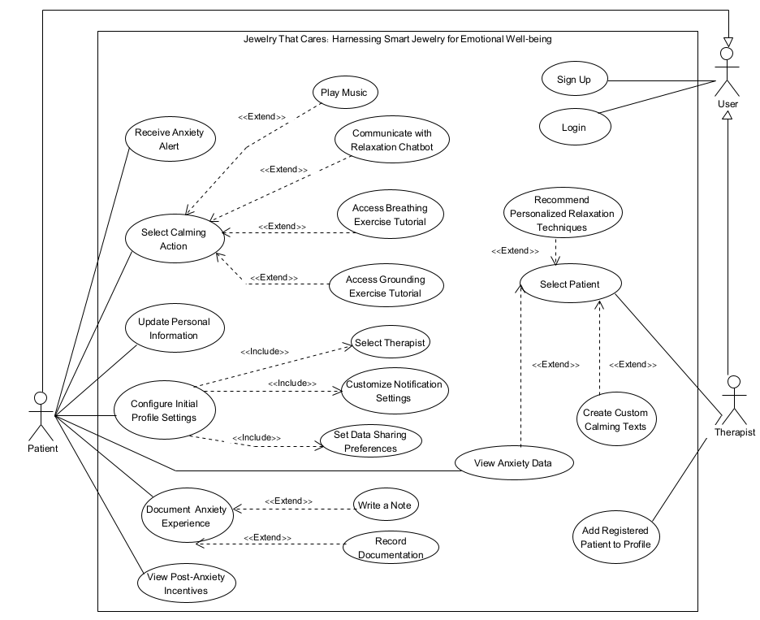

*fig 4. Use Case diagram*

# 5.3 Activity Diagram

**5.3.1 Patient and the system**

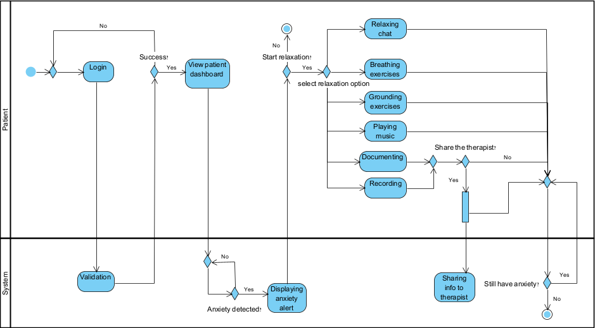

**5.3.2 Therapist and the system**

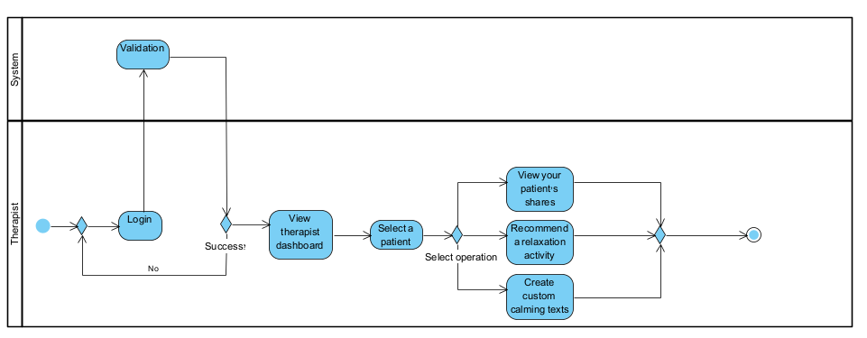

**5.3.3 The system**

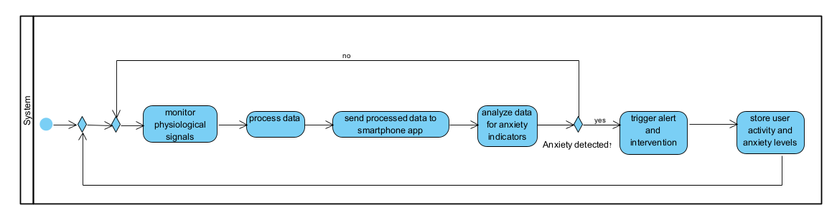

*fig 5. Activity diagram*

# 5.4 Application Screen Sketches

*fig 6. The app will alert you of anxiety in real time* 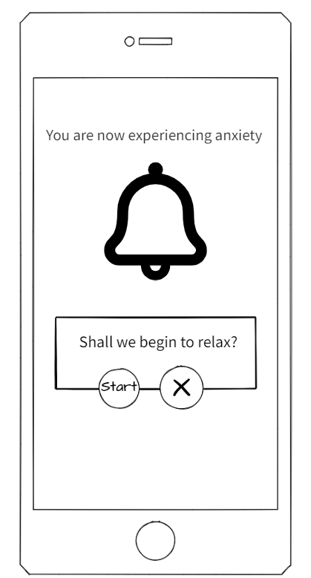

*fig 7. The application will display a main screen that includes showing progress by accumulating coins, viewing the personal profile and offering calming actions in order to deal well with anxiety*

*fig 8. One of the calming actions is writing a personal diary (including writing documentation)*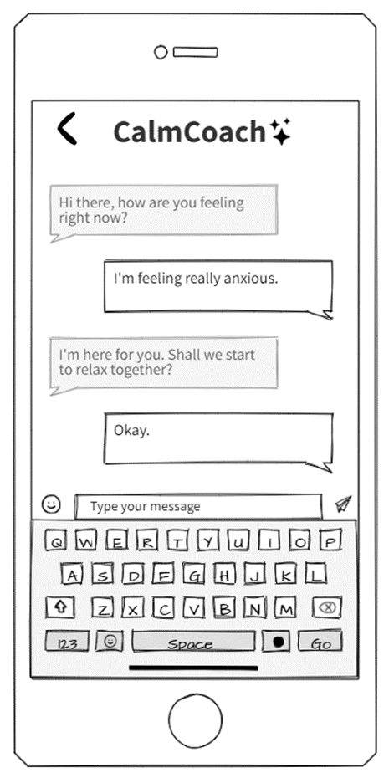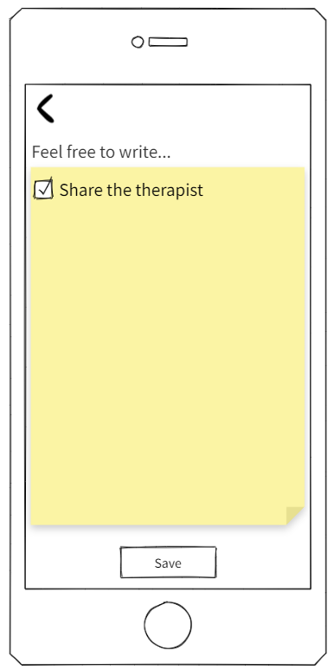

*fig 9. Another calming action is using a calming chat bot that knows how to deal with people who experience anxiety*

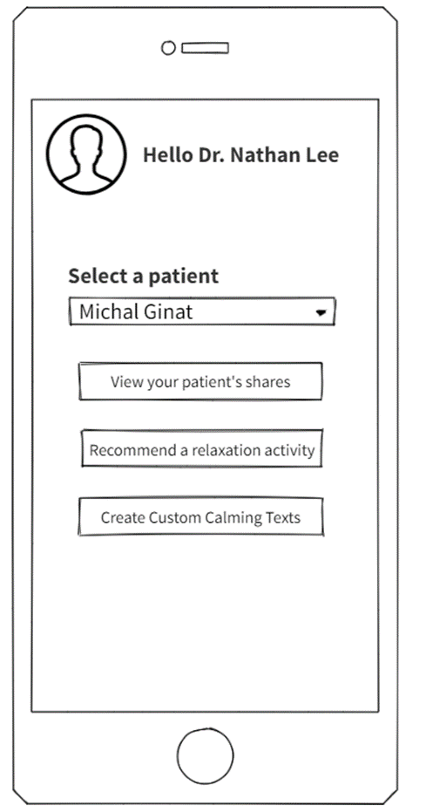

*fig 10. A personal profile that includes personal information as well as reports and information about the anxiety attacks*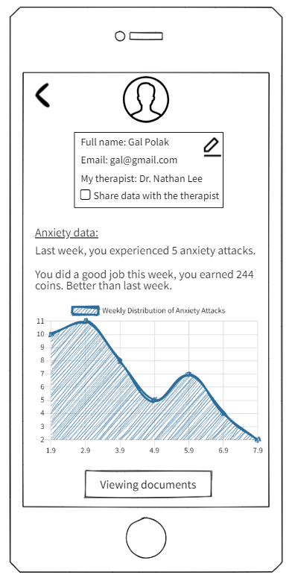

*fig 11. Main screen of the therapist. From this screen, we can access a view of the patient's details and anxiety data(As can be seen in the patient data), but only if the patient has given their consent.*

# 6. Expected Achievements

**Real-Time Anxiety Detection:** The system will reliably detect anxiety episodes in real-time using sensor data from the wearable device, ensuring timely intervention and support.

**Personalized Therapeutic Interventions:** Patients will receive customized calming actions based on their preferences and the severity of the anxiety episode, enhancing the effectiveness of anxiety management.

**Therapist-Patient Collaboration:** The system will facilitate continuous collaboration between therapists and patients by sharing detailed reports and progress tracking, enabling tailored treatment plans.

**User-Centric Design:** The application will be designed with a focus on ease of use, ensuring accessibility for patients with varying levels of technological proficiency and minimizing the learning curve.

**Secure and Compliant Data Management:** All patient data, including anxiety episode records and therapeutic notes, will be securely stored and transmitted, complying with relevant data protection regulations.

# 6.1 Challenges

**Sensor Data Analysis**: Accurately interpreting the physiological data from the wearable sensors to confidently detect anxiety episodes is the primary challenge.

**Real-Time Data Processing:** Managing and processing sensor data in real-time to trigger timely interventions, while maintaining system performance and responsiveness.

**User Engagement:** Encouraging consistent use of the application and wearable device, particularly in stressful situations where users may be less inclined to engage with technology.

**Data Privacy and Security:** Protecting sensitive patient data from unauthorized access or breaches while maintaining compliance with regulations such as GDPR ([General Data Protection Regulation](https://gdpr-info.eu/)) and HIPAA (Health Insurance Portability and Accountability Act).

**Scalability:** Designing the system to support an increasing number of users, sensor data, and stored records without compromising performance.

# 

# 6.2 Success Criteria

**Detection Accuracy:** Achieving a detection accuracy rate of at least 80% for anxiety episodes, with a response time of under 30 seconds from detection to intervention.

**User Adoption and Satisfaction:** Targeting an 70% adoption rate among patients and therapists, with satisfaction ratings of 85% or higher, indicating the system’s usability and effectiveness.

**Therapeutic Outcomes:** Demonstrating a measurable improvement in patient outcomes, such as reduced frequency and intensity of anxiety episodes, through regular use of the application.

**Data Security Compliance:** Ensuring 99% compliance with data protection regulations and achieving zero security breaches or data loss incidents.

**Scalability and Performance:** Supporting at least 10,000 concurrent users without significant performance degradation, and ensuring that the system remains responsive under high loads.

# 7. Testing Plan

# 7.1 Scope

Comprehensive testing of all mobile interfaces, backend functionalities, sensor data processing, and user interactions under real-world conditions. This will include testing how the wearable device interacts with the mobile application and how accurately anxiety is detected and managed.

# 7.2 Objectives

* Ensure that the mobile app and wearable device function according to the specifications.
* Validate the user interface for ease of use, accessibility, and intuitiveness, especially during anxiety episodes.
* Confirm the accuracy of anxiety detection based on sensor data.
* Validate the effectiveness of interventions (e.g., breathing exercises) provided by the app.
* Ensure that real-time data synchronization between the wearable device and the app is seamless and reliable.
* Safeguard sensitive user data through rigorous security testing, focusing on data transmission between the wearable device, mobile app, and backend.

# 7.3 Testing Approach

We will employ Jest (JavaScript testing framework) and React Native Testing Library for unit and integration tests across the mobile application. The focus will be on achieving high code coverage, especially for modules responsible for processing sensor data and triggering interventions. Automated testing will simulate user interactions, sensor input, and data processing under various conditions to ensure the app's robustness and reliability. Additionally, manual testing will be conducted to simulate real-world scenarios, such as anxiety attacks, ensuring that the app provides timely and effective interventions.

# 7.4 Constraints and Assumptions in Testing

Constraints:

* Limited access to varied real-world sensor data, necessitating the use of simulated data for some test cases.
* Dependency on stable internet connectivity for real-time data synchronization.
* Potential delays in integration testing due to limited availability of wearable devices and sensors.

Assumptions:

* The wearable device’s sensor data is accurate and reliable.
* Users will follow the app's recommended interventions during anxiety episodes.
* The app will primarily be used on modern smartphones with sufficient processing power and memory**.**

# 7.5 Description of the Testing Work Environment

Devices:

* Testing will be conducted on a range of Android and iOS devices to ensure compatibility and performance consistency.

# Network:

# Testing will be conducted on both stable Wi-Fi and cellular networks to simulate real-world usage conditions.

# Offline testing scenarios will be performed to evaluate the app’s behavior during network outages.

# Data:

# Use of simulated sensor data for stress testing.

# Real-time data from wearable devices for functional testing.

# 

# 7.6 Test Cases

| **Test Area** | **Test Name** | **Description** | **Procedure** | **Expected Result** |
| --- | --- | --- | --- | --- |
| **Login Functionality** | Successful User Login | Verify that a user can log in with correct credentials. | Enter username and password. Press "Login". | User is successfully logged in. |
| **Anxiety Detection** | Accurate Anxiety Detection | Test the accuracy of anxiety detection based on sensor data. | Simulating the sensor metrics using the wearable device. | App correctly identifies the user as experiencing anxiety. |
| **Intervention Trigger** | Breathing Exercise Trigger | Verify that the app triggers a breathing exercise during anxiety. | Simulate anxiety detection. Observe the app’s response. | The app starts a breathing exercise intervention. |
| **Data Sync** | Real-Time Data Synchronization | Confirm real-time data sync between the wearable and mobile app. | Perform actions with the wearable device and observe data in the app. | Data syncs in real-time without delay. |
| **Offline Functionality** | Core Feature Accessibility | Confirm critical features are accessible offline. | Simulate network outage and attempt to access core features. | Core functionalities remain operational. |
| **Security** | Data Transmission Security | Verify secure transmission of data between devices and backend. | Analyze data transmission using security tools. | Data is encrypted and secure. |
| **Usability Testing** | User Interface Usability | Conduct sessions to identify usability issues. | Interview users and simulate real-world scenarios. | Positive feedback and actionable items for improvement. |

*table 7. test cases of our application*

# 8. References

1. Bhattacharya, S., Goicoechea, C., Heshmati, S., Carpenter, J. K., & Hofmann, S. G. (2023). Efficacy of cognitive behavioral therapy for anxiety-related disorders: A meta-analysis of recent literature. Current psychiatry reports, 25(1), 19-30.
2. Bonato, P. (2010). Wearable sensors and systems. IEEE Engineering in Medicine and Biology Magazine, 29(3), 25-36.
3. Can, Y. S., Arnrich, B., & Ersoy, C. (2019). Stress detection in daily life scenarios using smart phones and wearable sensors: A survey. *Journal of biomedical informatics*, *92*, 103139.‏
4. Drissi, N., Ouhbi, S., Idrissi, M. A. J., & Ghogho, M. (2020). An analysis on self-management and treatment-related functionality and characteristics of highly rated anxiety apps. *International journal of medical informatics*, *141*, 104243.‏
5. Gülcüoğlu, E., Ustun, A. B., & Seyhan, N. (2021). Comparison of Flutter and React Native Platforms. *İnternet Uygulamaları ve Yönetimi Dergisi*, *12*(2), 129-143.
6. Hickey, B. A., Chalmers, T., Newton, P., Lin, C. T., Sibbritt, D., McLachlan, C. S., ... & Lal, S. (2021). Smart devices and wearable technologies to detect and monitor mental health conditions and stress: A systematic review. *Sensors*, *21*(10), 3461.
7. [https://trends.google.com/trends/explore?date=2022-07-20%202024-07-20&geo= IL&q=%D7%97%D7%A8%D7%93%D7%94&hl=en-GB](https://trends.google.com/trends/explore?date=2022-07-20%202024-07-20&geo=IL&q=%D7%97%D7%A8%D7%93%D7%94&hl=en-GB)
8. <https://alphacode.dev/backend/top-backend-technologies-2024/>
9. <https://www.turing.com/resources/backend-frameworks#top-10-backend-frameworks-in-2024>
10. <https://www.lambdatest.com/blog/flutter-vs-react-native/>
11. <https://www.bitcot.com/best-database-for-web-applications/#:~:text=Leaders%20for%20modern%20web%20apps,reach%20%2471.6%20billion%20by%202026>.
12. <https://github.com/sidesh27/Anxiety-Detection?tab=readme-ov-file>
13. <https://github.com/rs2416/Detecting_Social_Anxiety>
14. <https://aws.amazon.com/iot-core/faqs/>
15. <https://db-engines.com/en/system/MongoDB>
16. <https://db-engines.com/en/system/PostgreSQL>
17. Ihmig, F. R., Neurohr-Parakenings, F., Schäfer, S. K., Lass-Hennemann, J., & Michael, T. (2020). On-line anxiety level detection from biosignals: Machine learning based on a randomized controlled trial with spider-fearful individuals. *Plos one*, *15*(6), e0231517.‏
18. Javaid, S. F., Hashim, I. J., Hashim, M. J., Stip, E., Samad, M. A., & Ahbabi, A. A. (2023). Epidemiology of anxiety disorders: global burden and sociodemographic associations. *Middle East Current Psychiatry*, *30*(1), 44.
19. Nakao, M., Shirotsuki, K., & Sugaya, N. (2021). Cognitive–behavioral therapy for management of mental health and stress-related disorders: Recent advances in techniques and technologies. *BioPsychoSocial medicine*, *15*(1), 16.
20. Sharma, N., & Gedeon, T. (2012). Objective measures, sensors and computational techniques for stress recognition and classification: A survey. *Computer methods and programs in biomedicine*, *108*(3), 1287-1301.‏
21. Shaukat-Jali, R., van Zalk, N., & Boyle, D. E. (2021). Detecting subclinical social anxiety using physiological data from a wrist-worn wearable: small-scale feasibility study. *JMIR Formative Research*, *5*(10), e32656.‏
22. Verma, N., Singh, S., & Prasad, D. (2022). A review on existing IoT architecture and communication protocols used in healthcare monitoring system. *Journal of The Institution of Engineers (India): Series B*, *103*(1), 245-257.